CS303 LAB #2 Report

Zeynep Yıldız 00029325

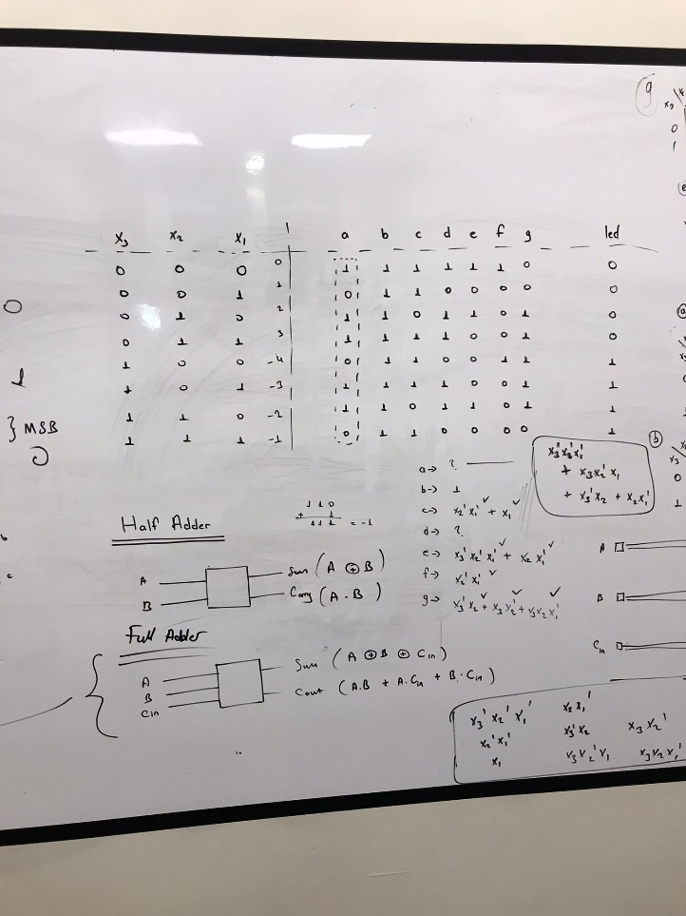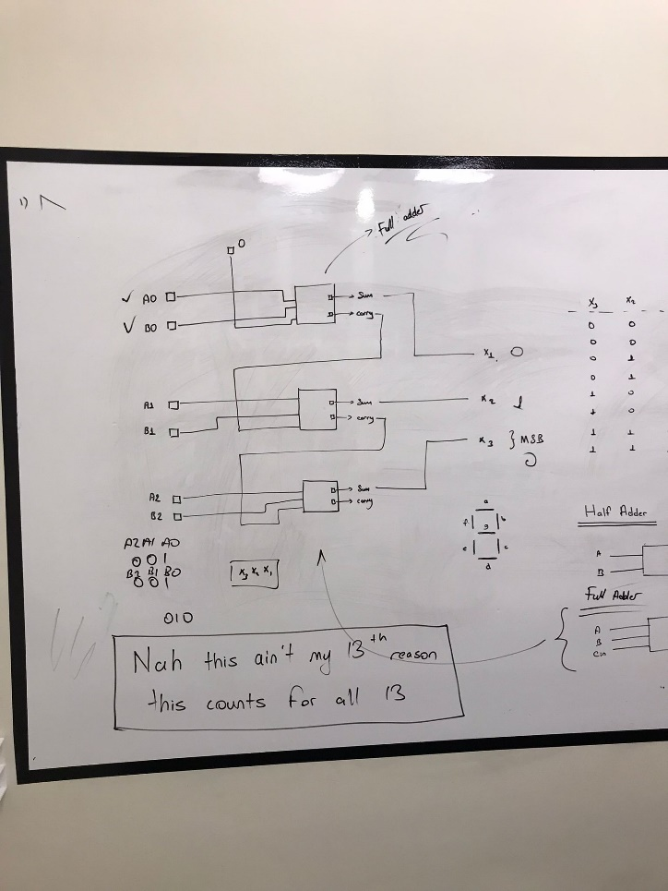At first, I designed the circuit and then made a truth table.

And then I make K-maps for each of the sides (a,b,c,d,e,f,g) of seven-segment display.

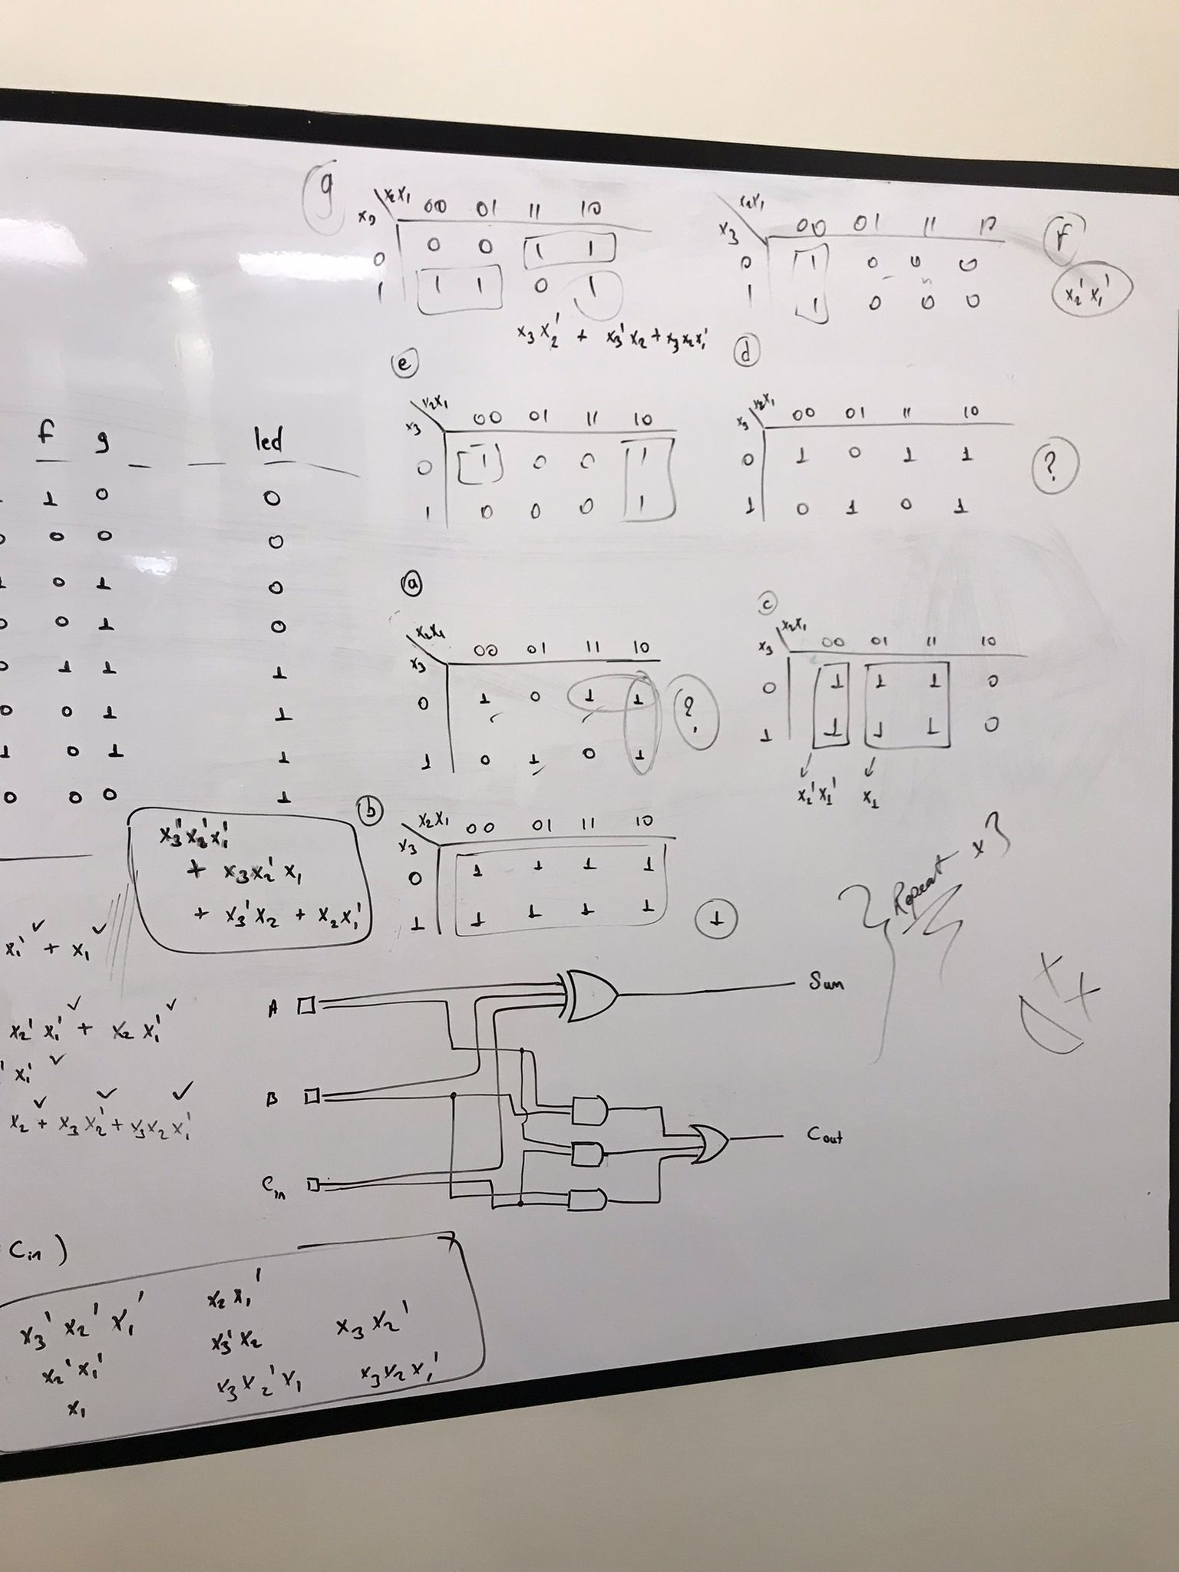

And after creating all the functions I inserted them in digital software

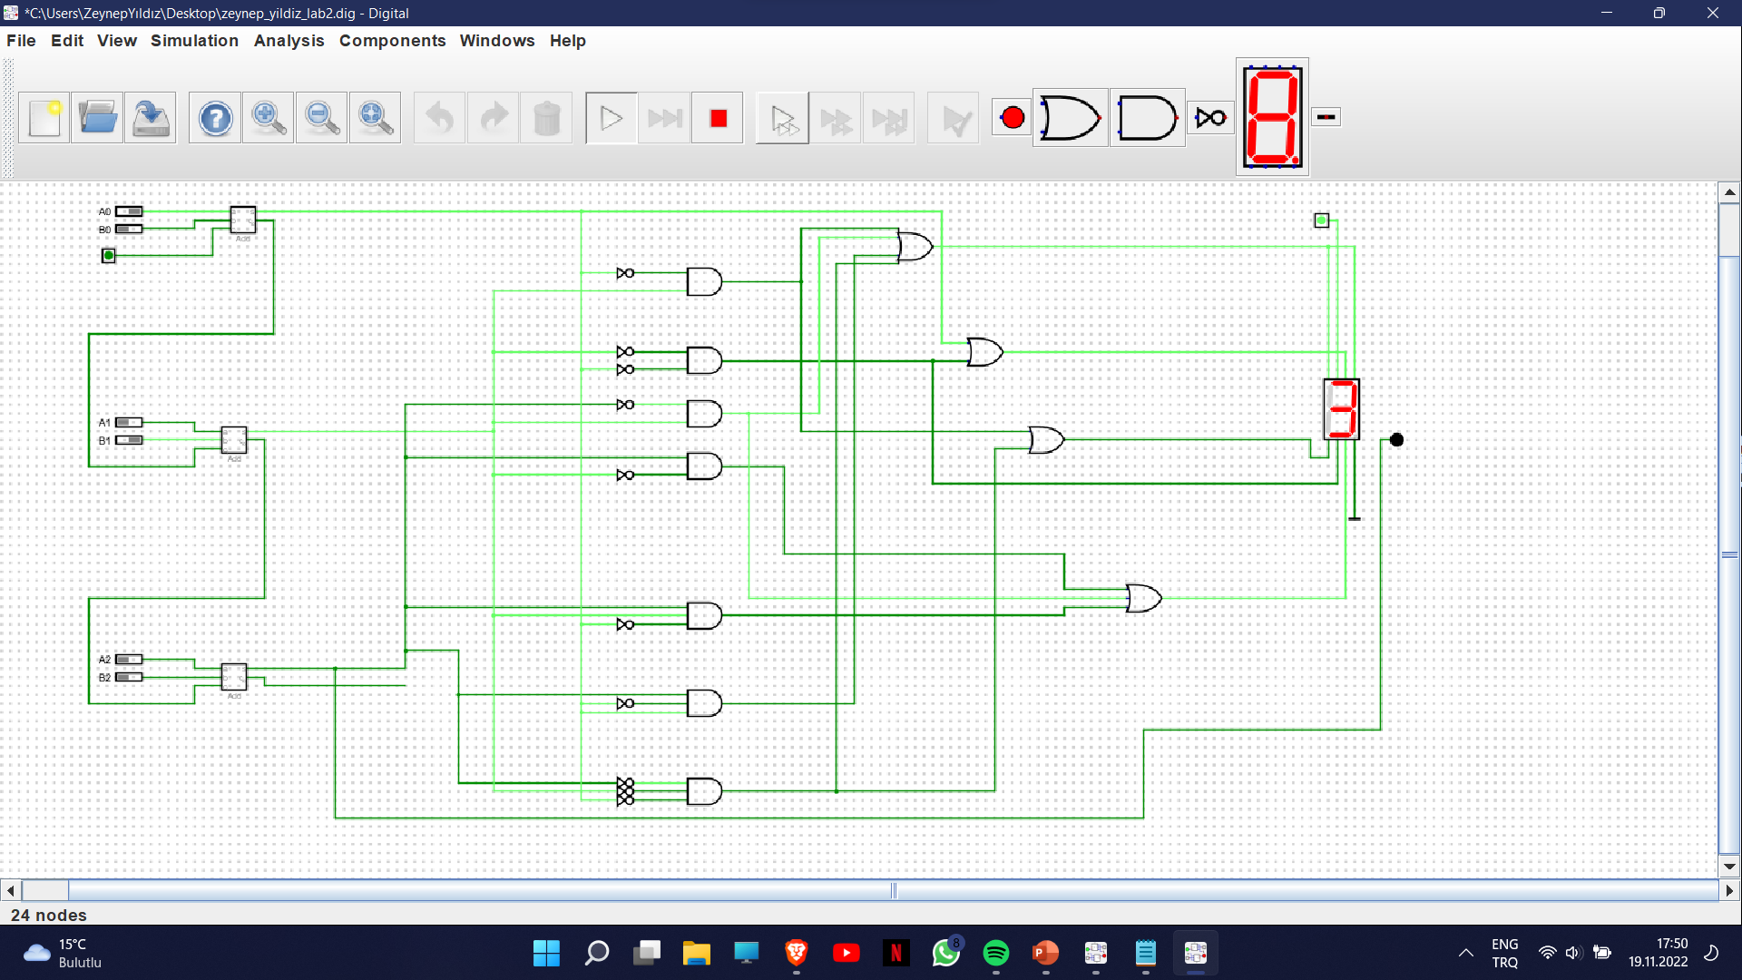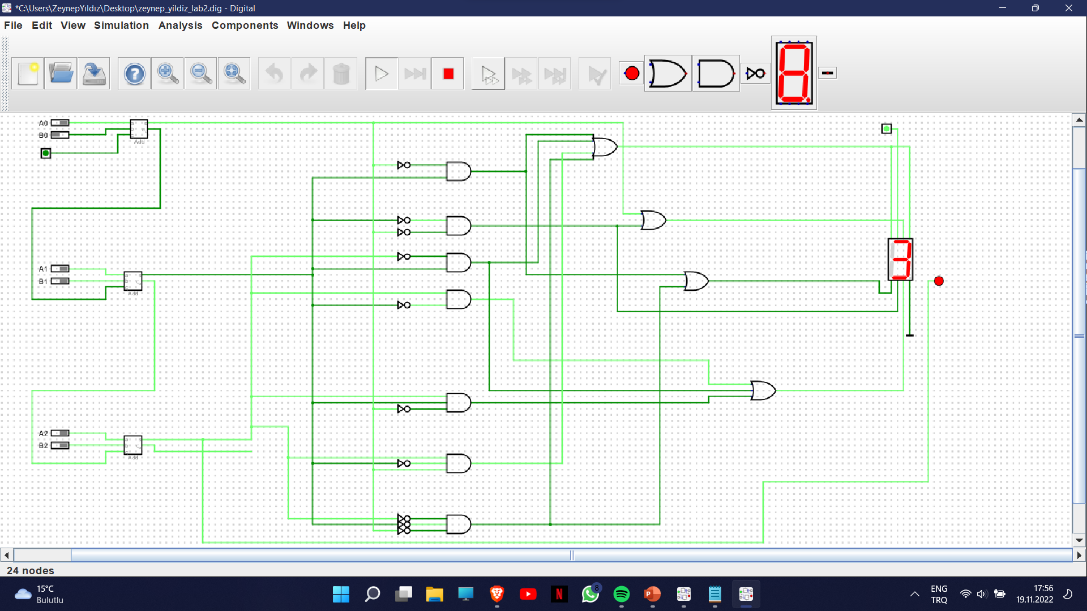

These are some examples.